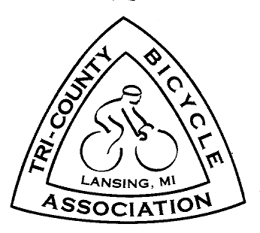

TRI – COUNTY BICYCLE ASSOCIATION
P.O. Box 22146 Lansing, MI 48909-2146 www.biketcba.org

East Lansing City Council
410 Abbot Road, Room 100
East Lansing, MI 48823
Meridian Township Board
5151 Marsh Road
Okemos, MI 48864

November 3, 2016

Dear Council and Board Members:

The Tri-County Bicycle Association (TCBA), the area’s bicycle club with over 900 members, have watched with interest the Costco Development on Park Lane Road. Based on the article that appeared on the East Lansing Info website (http://www.eastlansinginfo.org/content/costco-plan-moves-forward-details-emerge), we have concerns with the non-motorized transportation (NMT) aspects of the project.

Costco representative Ted Johnson stated that the store will cater overwhelmingly to consumers that would drive to the store. Thus, his company does not need to comply with the East Lansing building codes that ensure access for NMT users. TCBA feels that East Lansing and Meridian Township should not adopt waivers to these codes.

First, both the City and Township have programs and policies that promote healthy living. An area that is designed not to provide access to pedestrians and bicyclists goes against these programs. A senior independent living project (The Marquette), a large subdivision, and a condo development are within a short walk or ride of the proposed store.

Area governments have been working on a network of bike lanes and pathways that link their communities. Meridian Township’s Non-Motorized Plan calls for a seven to ten-foot pathway along eastbound Saginaw from the corner of Park Lake Road connecting with the pathway at the intersection of Saginaw and Lake Lansing Road (near Rite-Aid).

Also, the NMT plan calls for the existing pathway along Park Lake Road from Haslett Road to Saginaw to be completed/updated. The County Road Department wants to add bike lanes to Park Lake. Instead of trying to complicate NMT projects, Costco should work with governments to provide the necessary infrastructure for healthy living.

Second, a sidewalk leading from Saginaw Highway to the front entrance of the store and sufficient bike racks would be a visible statement to the community that Costco welcomes all kinds of consumers. Walkers and cyclists now have a good choice of cargo devices. They will go to Costco if the store provides for them.

We do applaud Costco’s providing indoor parking space for its employees. However, they should not be included in the total number of public bike racks required by the East Lansing building code.

Third, Costco has bike racks in stores in these cities: Chicago, Milwaukee, Brighton, Michigan, and Mountain View, California. The Mountain View racks were not part of the original construction, but it would have been cheaper for Costco and more convenient for customers if they were. See: https://ladyfleur.bike/2014/10/28/extreme-bike-shopping-john-jenny-at-costco/

In summary, the Tri-County Bicycle Association wants the existing codes followed because it will benefit the future customers of Costco. We are willing to work with all parties to make this happen.

Sincerely,

Michael Unsworth
Chair, Advocacy Committee
Tri-County Bicycle Association
1518 Haslett Road, Unit 635
Haslett MI 48840
advocacy@biketcba.org
517-282-7515

XC: Ted Johnson

